Patch Panel Re-Termination & Verification
Ports T1–T3 (sanitized example)
Documentation created: 2026-02-25
Location / Site: Communications cabinet (anonymized)
Version (V1.0)
Security note: This is a sanitized portfolio example. Real site names, room names, services, and exact port mappings have been removed or generalized.

1. Goal
Reason / Trigger: No link on target patch panel ports T1–T3
Re-terminate and verify three network cable runs (T1–T3 shown as example identifiers) on the patch panel. Confirm continuity and correct termination, then label the ports and prove end-to-end connectivity by patching from the patch panel to the switch.

2. Scope
This procedure covers: identifying runs P13–P15, initial testing, removing the patch panel, punching down the cable pairs, reinstalling the panel, re-testing, labeling, and final switch connectivity checks.

3. Tools & Materials
- RJ45 cable tester (master + remote unit)
- Punch-down tool (110/Krone style as required by the patch panel)
- Side cutters / flush cutters (for trimming conductors)
- Screwdriver (for rack/patch panel screws)
- Labelmaker (to label ports T1–T3 (example) and cable runs)
- Patch cords (to connect patch panel ports to the switch)
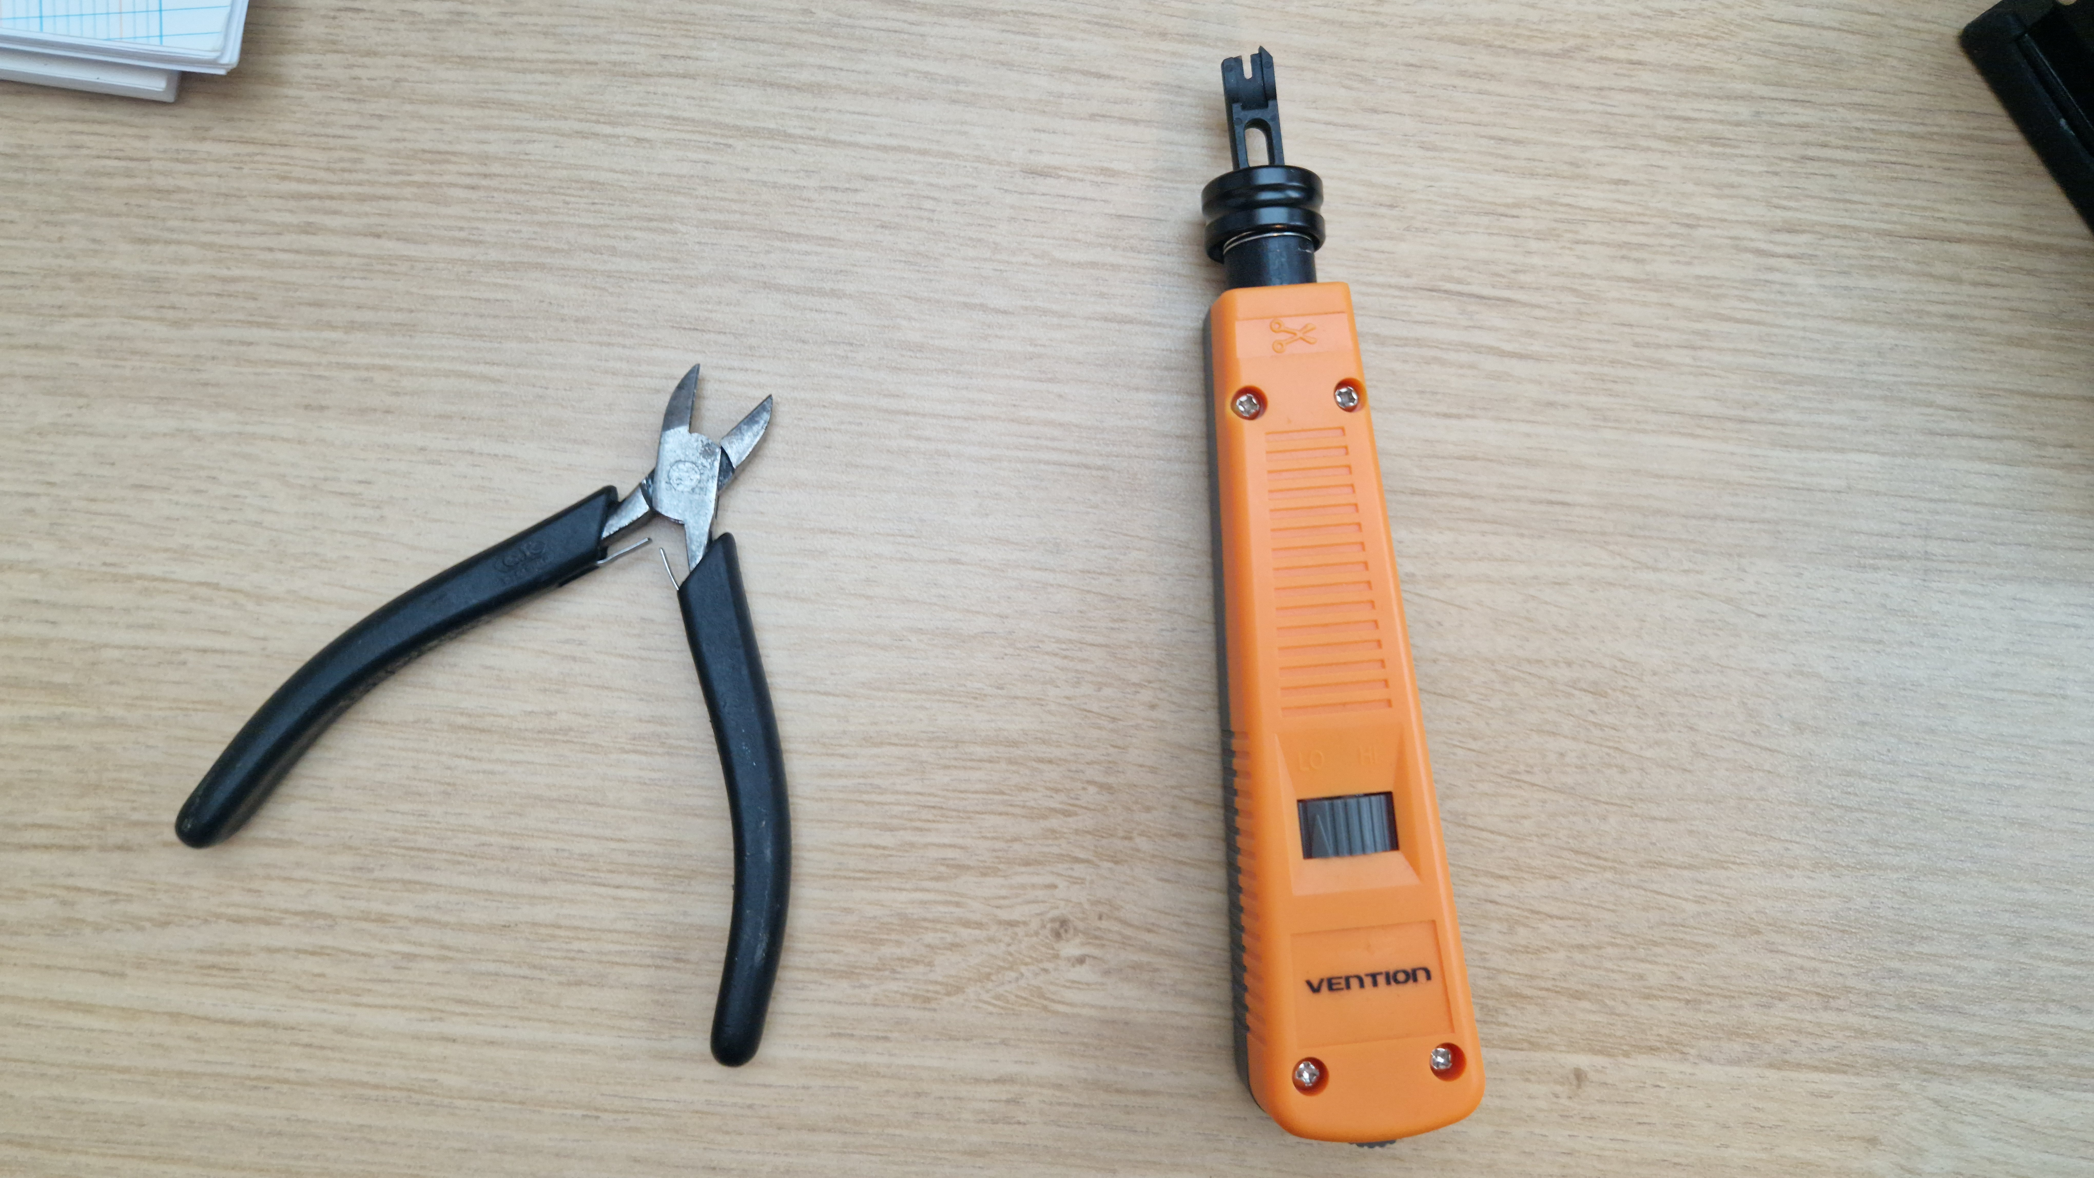

4. Safety / Good Practice
- Keep twists as close as possible to the termination (minimal untwist) for best performance.
- Do not nick or cut conductor insulation when stripping the jacket.
- Ensure the cable jacket is secured in the strain relief area (if your patch panel provides one).

5. Procedure (Step-by-step)
TIA-568B wire order (pin 1 → 8):
- 1. White-Orange
2. Orange
3. White-Green
4. Blue
5. White-Blue
6. Green
7. White-Brown
8. Brown
Note: Follow the patch panel’s printed T568A/T568B legend and ensure both ends use the same standard (T568B in this example).
1. Identify the target runs (P13–P15).
Locate the incoming cables that correspond to patch panel ports P13, P14, and P15. Confirm the cable numbers/labels on the sheath if present.

2. Initial continuity test.
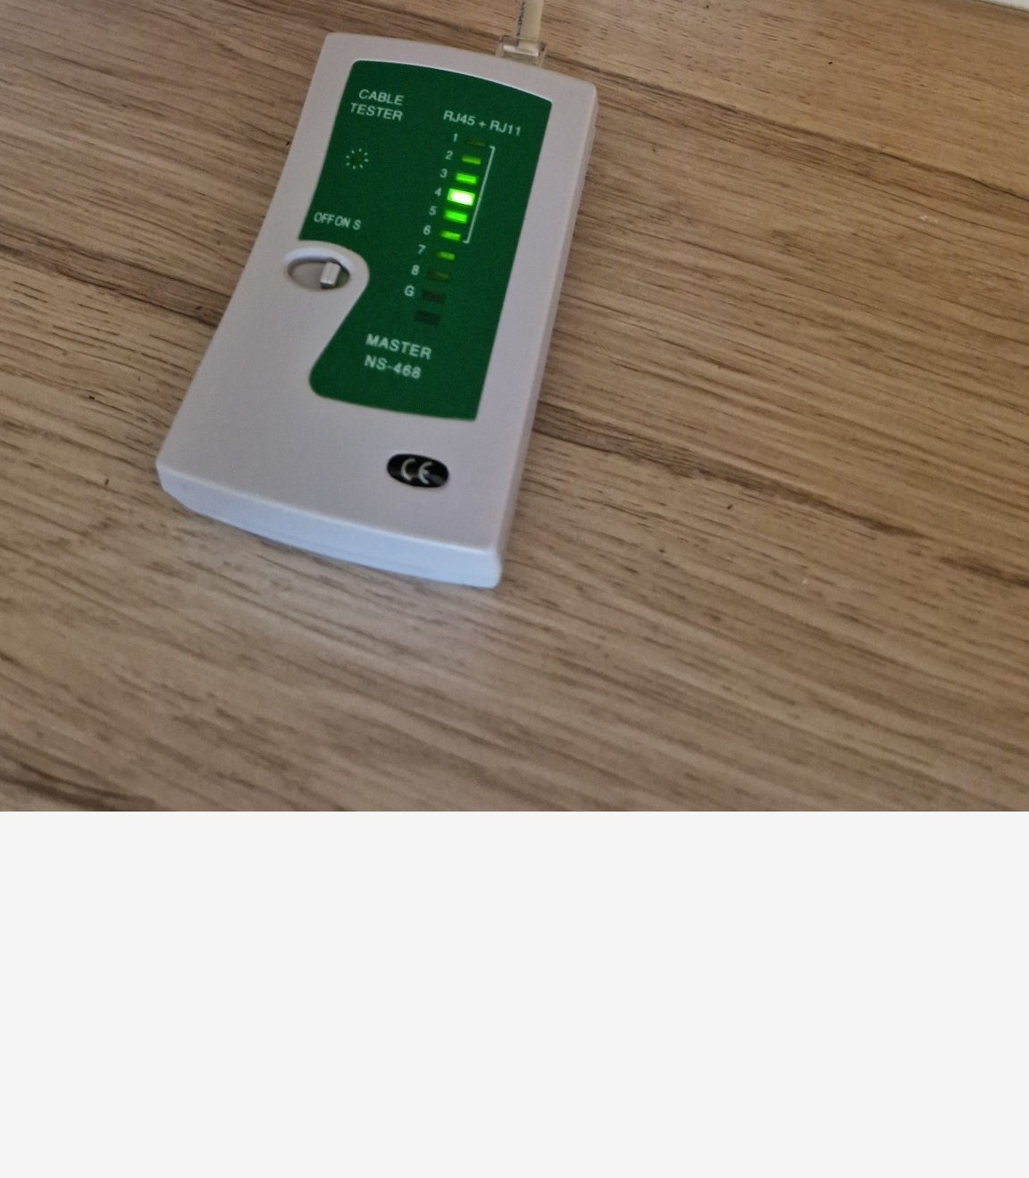
Before making changes, test each run using the cable tester (master at one end, remote at the other). Observe the LED sequence. A normal pass is a clean 1→8 sequence.

3. Remove the patch panel for access.
- Remove the white side clips
- Remove the screws on both ends (1 per side)
- Slide the insert/module out carefully to access the punch-down block
- Keep cables supported to avoid strain on IDC terminations
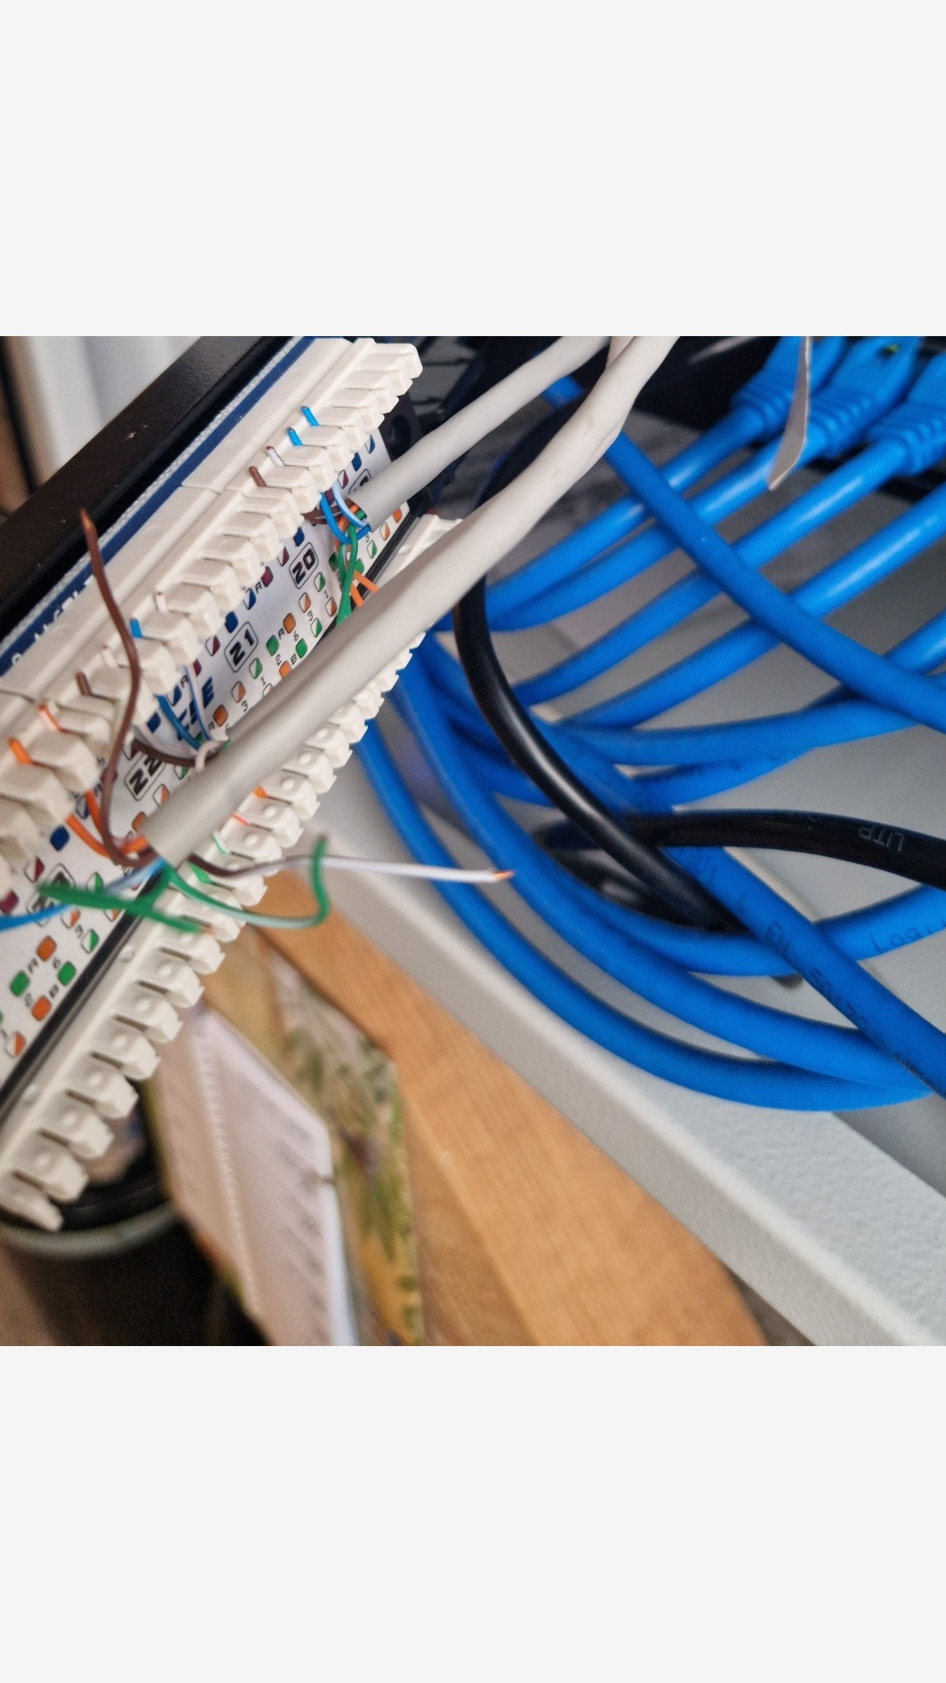
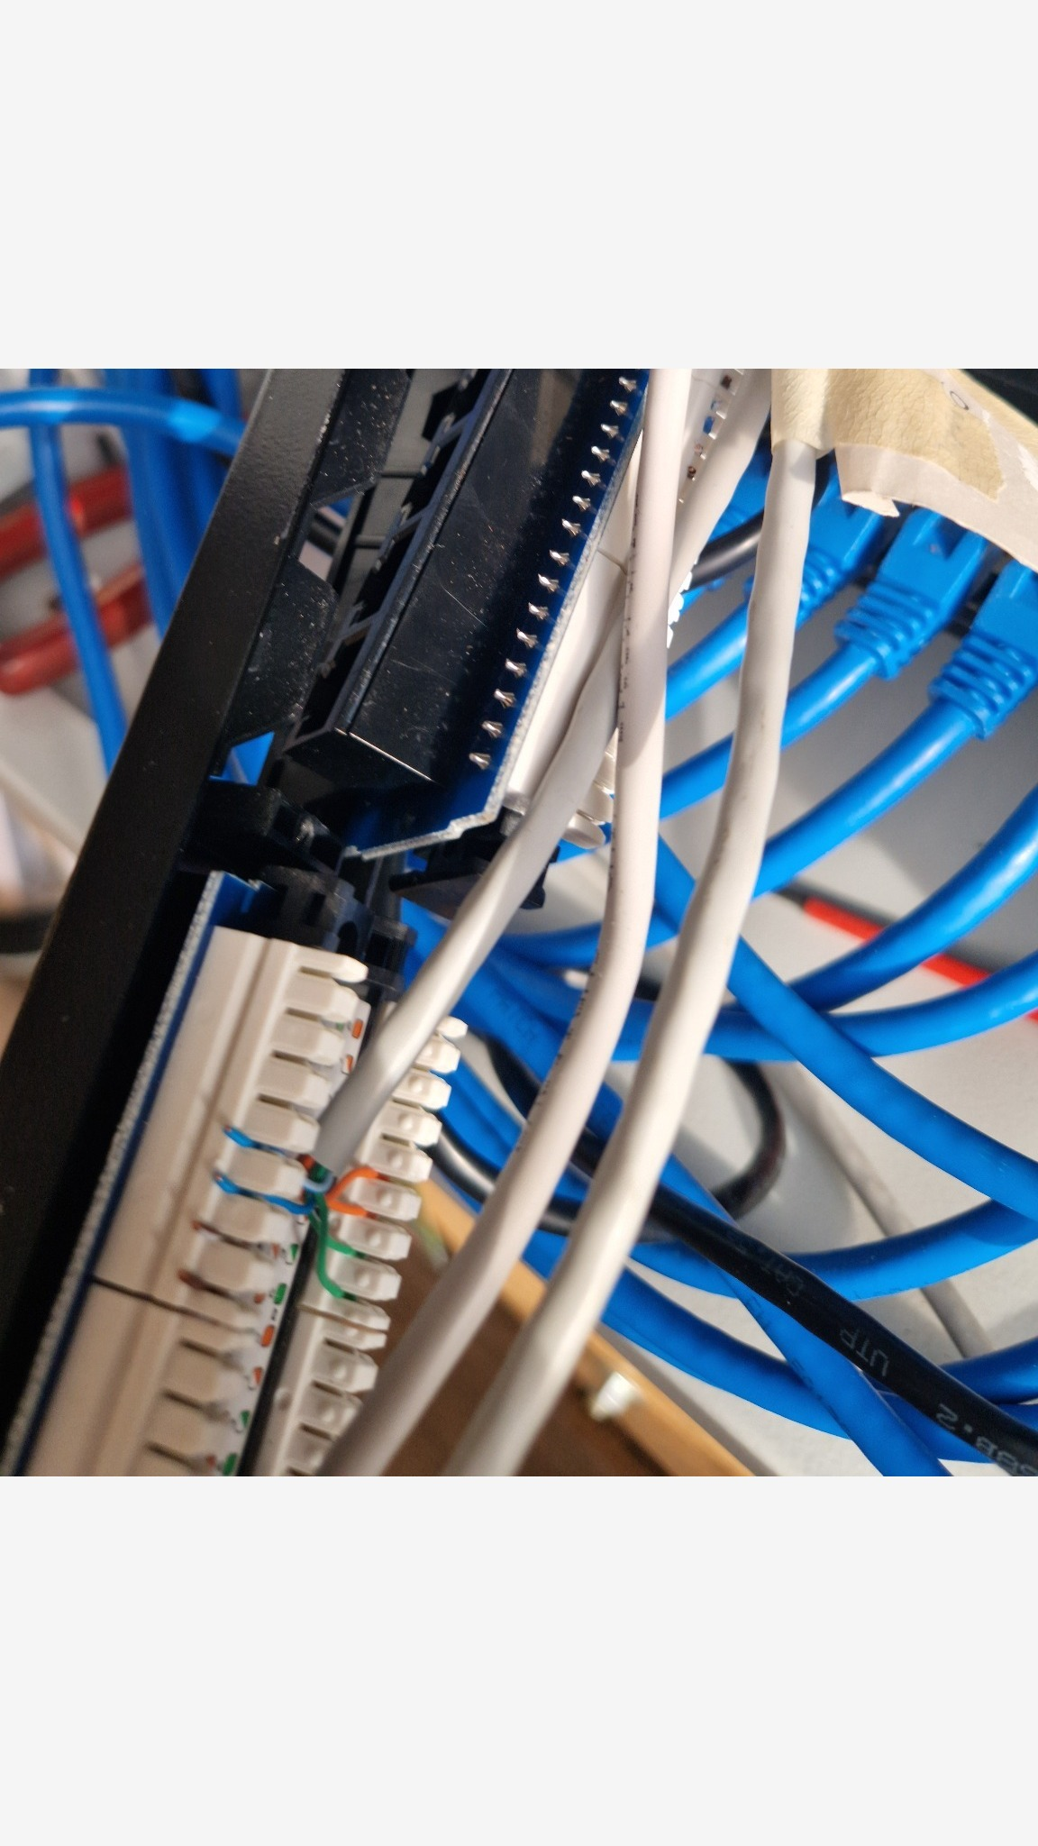

4. Prepare the cables (strip/peel).
Strip back the outer jacket enough to reach the punch-down block without tension. Do not strip more than needed. Keep the pairs twisted as close as possible to the punch points. 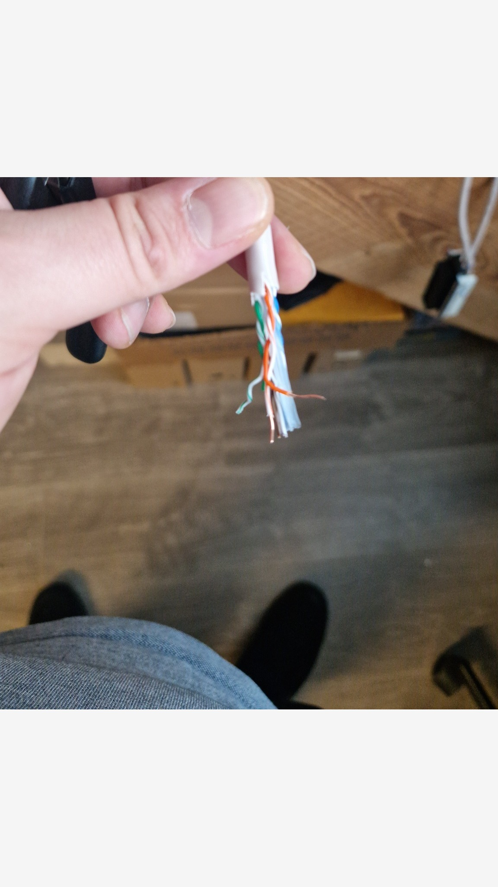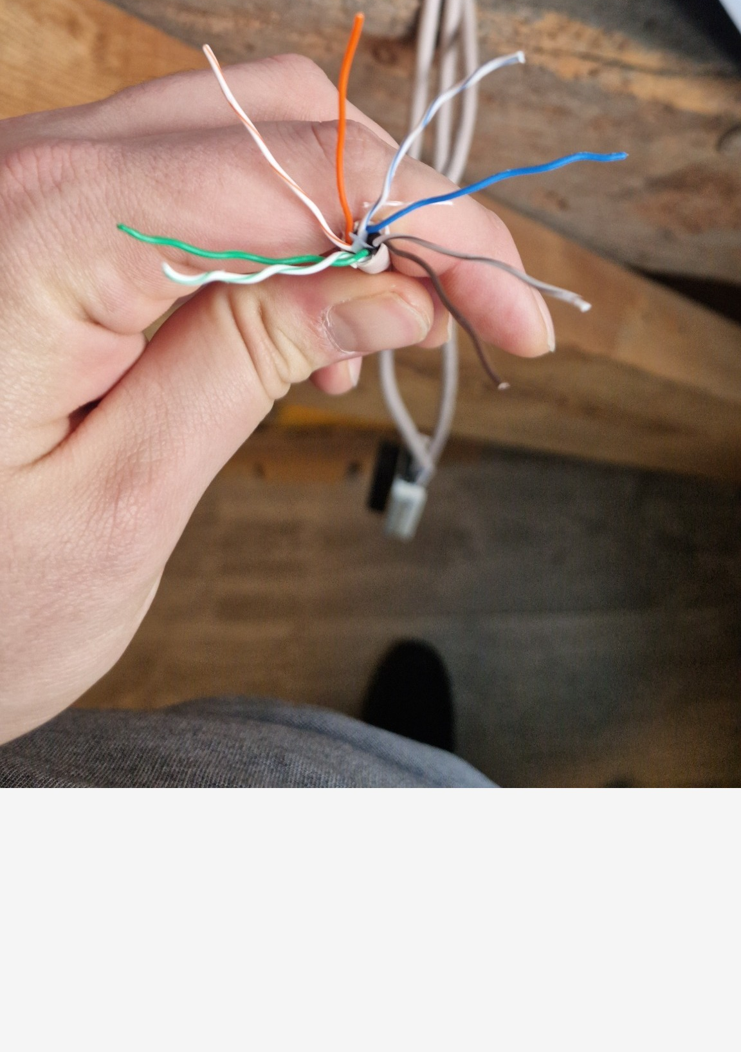
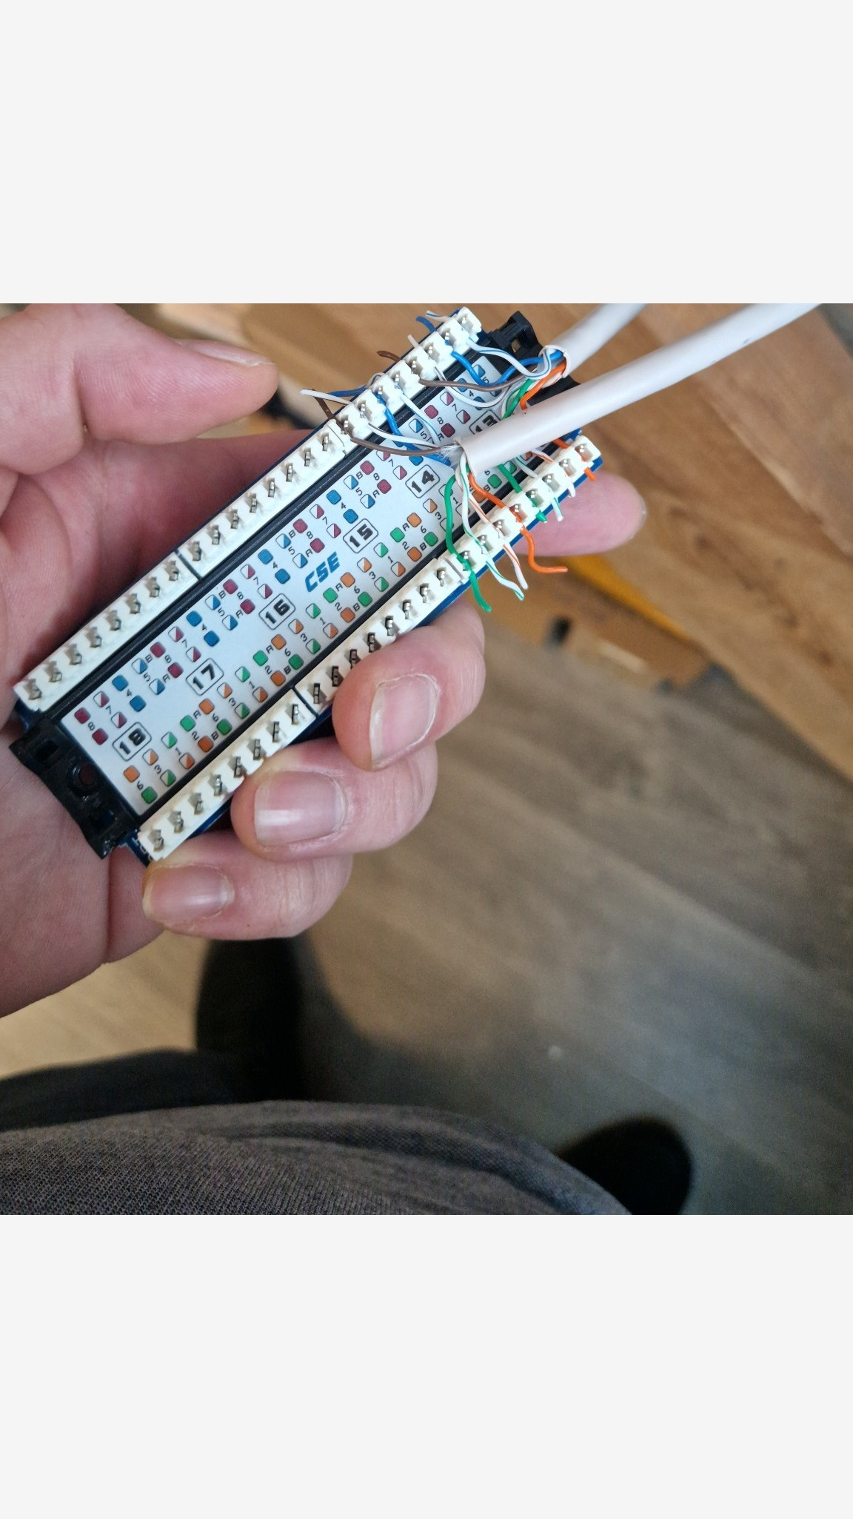
5. Punch down the conductors.
Using the color code printed on the patch panel TIA 568B, place each conductor into the correct IDC slot and punch down with the tool. Trim the excess conductor (often the punch-down tool trims automatically).
6. Repeat for the remaining target ports.
Terminate all three runs using the same standard B consistently.

7. Reinstall the patch panel.
Place the modules/insert back into the frame, put screws back in place, re-attach the clips, and mount the patch panel back in the rack.
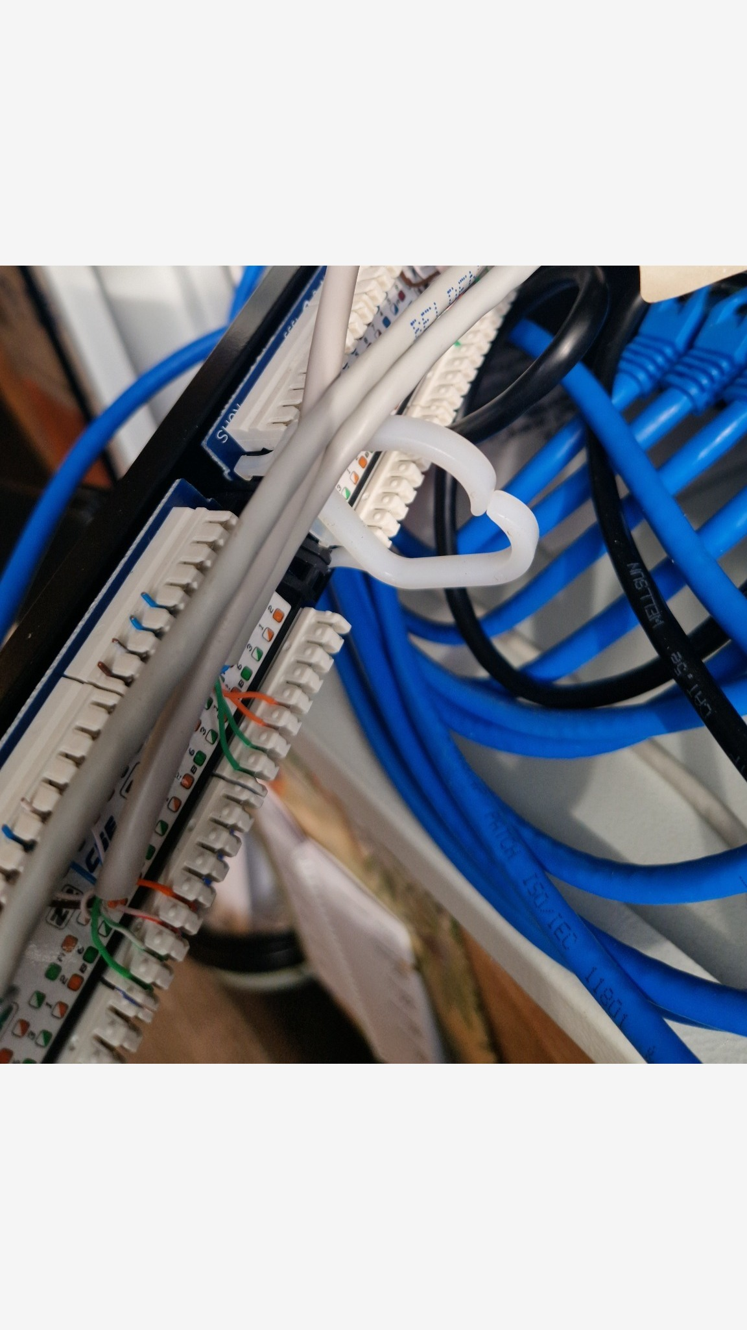
8. Re-test continuity.
Re-test ports T1–T3 using the cable tester to confirm correct termination after punch-down.
After re-termination, ports T1–T3 passed (1–8 sequential).

9. Label and document.
Label the target patch panel ports as T1, T2, and T3 (example identifiers) and label the corresponding destination/outlet (sanitized). This becomes the reference for future troubleshooting.
Patch Panel Port Overview
Zone / Outlet | Patch panel port # | Notes / Service
Zone B-04 | P1 | Legacy device
Zone E-05 | P2 | Unassigned
Zone G-08 | P3 | Lab / test point
Zone F-05 | P4 | IoT endpoint (generic)
Zone C-04 | P5 | —
Zone B-01 | P6 | —
Zone K-05 | P7 | —
Zone E-03 | P8 | —
Zone K-02 | P9 | Unassigned
Zone B-03 | P10 | Spare / reserved
Zone K-04 | P11 | —
Zone G-01 | P12 | Unassigned
Zone F-04 | T1 | —
Zone F-01 | T2 | —
Zone E-08 | T3 | —
Zone J-06 | P16 | IoT endpoint (generic)
Zone A-01 | P17 | Spare / reserved
Zone J-01 | P18 | VoIP endpoint (generic)
Note: The following Port Overview is randomized sample data (P1–P18) for portfolio demonstration and is not the real site mapping.
10. Final connectivity check to switch.
Patch ports T1–T3 (example) from the patch panel to available switch ports using patch cords. Verify link LEDs on the switch and confirm network connectivity (e.g., DHCP lease, ping, or switch MAC table).

Appendix A. Verification Checklist
- Cable tester shows a clean 1–8 sequence for each target port (T1–T3).
- No loose conductors; no exposed copper beyond the IDC.
- Cable jacket is secured; minimal untwist at termination.
- Patch panel is firmly re-mounted; no strain on terminations.
- Ports labeled; mapping is recorded.
- Switch shows link; endpoint has connectivity (as applicable).

Appendix B. Notes / Observations
If any tester LEDs do not light, light out of order, or show shorts/crossed pairs, re-check the punch-down color order and confirm both ends follow the same standard B. Also inspect for damaged conductors or insufficient punch-down seating.

Appendix C. Test Results (Before / After)
Record the cable tester outcome for each run (and any fault type observed).
Port | Before | Before notes | After | After notes
T1 | Unknown (not recorded) | — | Pass (1–8 sequential) | Reterminated T568B
T2 | Unknown (not recorded) | — | Pass (1–8 sequential) | Reterminated T568B
T3 | Unknown (not recorded) | — | Pass (1–8 sequential) | Reterminated T568B

Appendix D. Connectivity Proof (Patch Panel → Switch)
Patch ports T1–T3 (example) from the patch panel to the switch and verify link + connectivity.
Patch panel port | Switch port | Link LED | Proof (choose one) | Notes
T1 | S1 | Yes | Ping gateway | __________________
T2 | S2 | Yes | Ping gateway | __________________
T3 | S3 | Yes | Ping gateway | __________________

Appendix E. Change Log
Date: 2026-02-25
Change: Re-terminated patch panel ports T1–T3 (example) (TIA-568B).
Verified: Cable tester + switch link/network proof.
Performed by: M.C.
Public version: identifiers and mappings sanitized for security.

