Project: Hybrid Cloud Web Infrastructure & Security Implementation
Project Lead: Manuel Cipagauta Live Demo: manuelshomelab.com
Executive Summary
This project demonstrates the deployment of a production-ready web server using a hybrid infrastructure approach. The goal was to host a static portfolio website on on-premise virtualization hardware (Proxmox) while leveraging cloud-native networking (Cloudflare Zero Trust) to secure public access without exposing residential IP addresses or opening firewall ports.
Technical Stack
- Hypervisor: Proxmox VE 8.x (Bare Metal)
- Server OS: Windows Server 2022 (Desktop Experience)
- Web Server: Internet Information Services (IIS)
- Edge Network: Cloudflare Zero Trust (Tunneling Agent)
- Networking: Static IPv4, DNS Management, CGNAT Bypass.

Phase 1: Virtual Infrastructure Deployment
The foundation of the project is a virtualized environment running on bare-metal hardware.
- Hypervisor Configuration:
  - Utilized Proxmox VE to manage resources efficiently.
  - Network Configuration: Verified the Linux Bridge (vmbr0) connectivity to the gateway to ensure stable bridging for guest VMs.
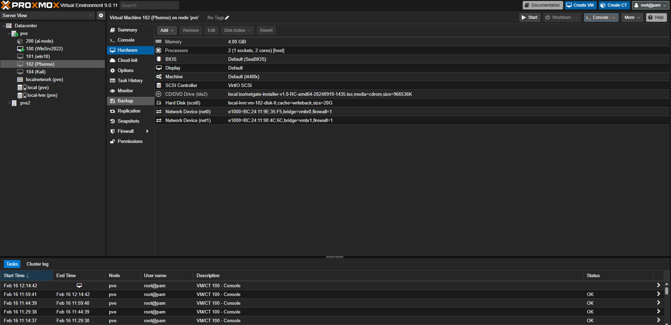

- Virtual Machine (VM) Provisioning:
  - OS: Windows Server 2022.
  - Resources: Allocated 2 vCPUs and 4GB RAM to ensure GUI responsiveness and smooth update handling.
  - Network Strategy: Configured a Static IP within the server to ensure consistent internal routing, preventing DHCP leases from breaking local connectivity.

🔹 Phase 2: Web Server Configuration (IIS)
Turning the raw OS into a functional web host using Microsoft's native tooling.
- Role Installation:
  - Accessed Server Manager and utilized the "Add Roles and Features" wizard.
  - Selected and installed Web Server (IIS) along with necessary management tools.
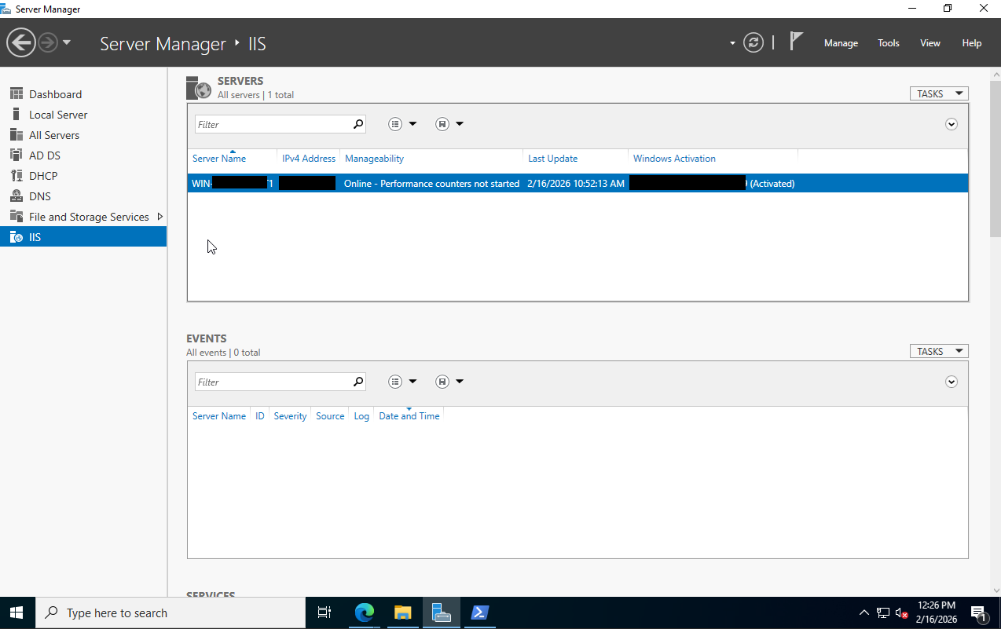
- Content Deployment:
  - Navigated to the IIS root directory: C:\inetpub\wwwroot.
  - Clean Up: Removed default IIS artifacts (iisstart.png) to ensure a clean slate.
  - Deployment: Transferred the custom HTML/CSS portfolio via RDP.
  - Critical Configuration: Renamed the entry file from HOME.html to index.html. This ensures the web server automatically serves the landing page without requiring the user to type the full file path.
- Local Validation:
  - Verified internal connectivity by browsing to http://localhost on the server and ip from the local network.
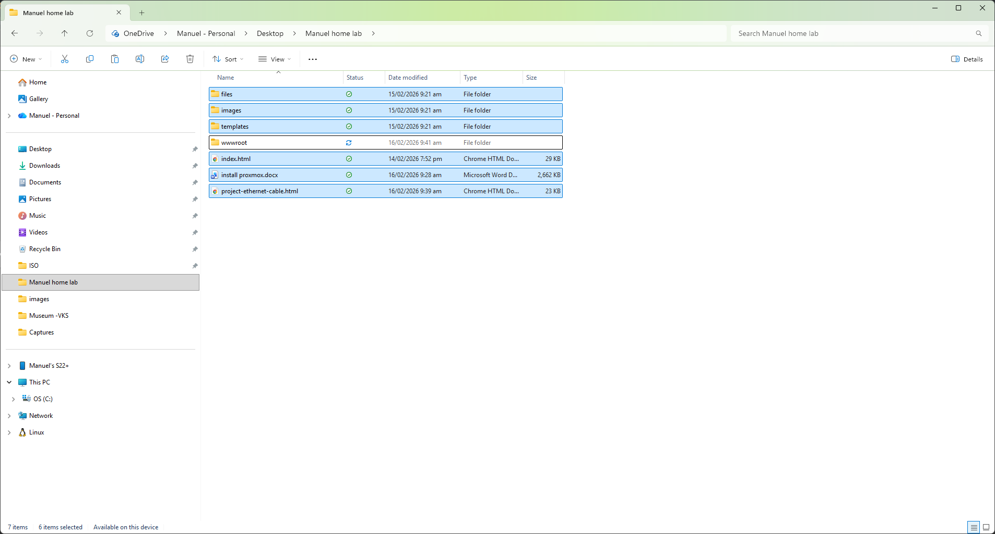

Phase 3: Cloud Networking & Security (Zero Trust)
The critical phase: exposing the local server to the public internet securely without Port Forwarding.
- Tunnel Initialization:
  - Leveraged Cloudflare Zero Trust to create a secure tunnel named HomeLab-Server.
  - This architecture establishes an outbound-only connection to Cloudflare’s edge, bypassing local router firewalls and Carrier-Grade NAT (CGNAT).

- Agent Installation:
  - Deployed the cloudflared agent on Windows Server 2022 via PowerShell (Administrator mode).
  - Verified the connector status changed to "Healthy", confirming the encrypted link between the home lab and the Cloudflare network.

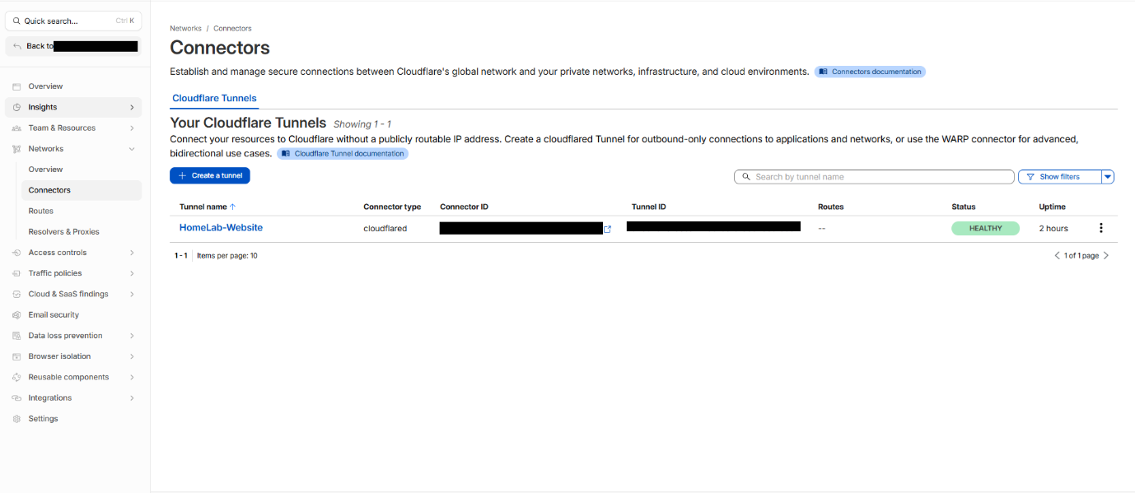
- Routing & Encryption:
  - Public Hostname: Configured www.manuelshomelab.com to route traffic to the tunnel.
  - Service Configuration: Mapped the internal service to HTTPS://localhost:443 as shown in the configuration.
  - Security Protocol: External visitors receive a fully valid SSL certificate managed by Cloudflare, ensuring an encrypted connection (Green Padlock) while masking the origin server's identity.

Final Result & Verification
- Public Access: The website is globally accessible at https://www.manuelshomelab.com.
- Security: The connection is secured with a valid SSL certificate, protecting visitor data.
- Resilience: The cloudflared agent runs as a Windows Service, ensuring the website comes back online automatically after a server reboot.
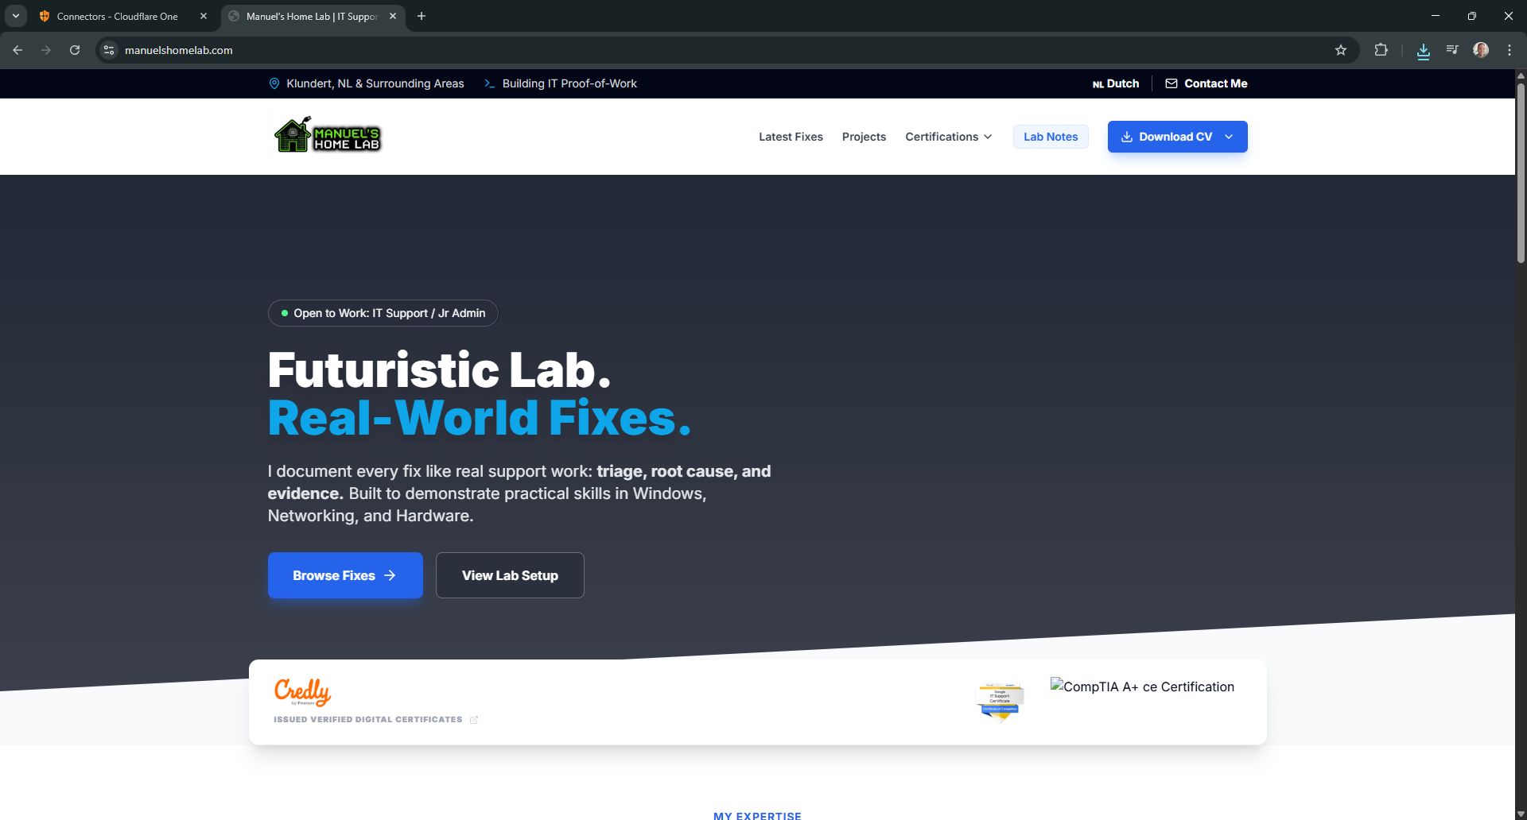
Key Troubleshooting Highlights
- Naming Conventions: Initially encountered 403/404 errors due to the main file being named HOME.html. Resolved by renaming to standard index.html.
- Tunnel Stability: Ensured the Cloudflare connector was installed as a system service to prevent disconnection when the user logs off.

