Project: Ethernet TIA-568B Termination & Infrastructure Setup
Project Lead: Manuel Cipagauta
Case Study: #1
Focus: Physical Layer & Network Infrastructure
Executive Summary
The objective of this project was to establish high-quality physical connectivity for a Home Lab environment. By creating custom-length patch cables, the goal was to minimize cable clutter in the server rack while ensuring maximum data throughput (Gigabit speeds) and zero packet loss. Standardizing on the TIA-568B protocol ensures universal compatibility with commercial networking equipment.
Technical Specifications
- Cable Type: Cat 5e (UTP)
- Connector: RJ45 (8P8C) Modular Plug
- Wiring Standard: TIA-568B
- Transmission Limit: 1 Gbps (Gigabit Ethernet)
- Tools Used: Radial Stripper, Flush Cutters, Crimping Tool, Continuity Tester.

Phase 1: Cable Preparation
Reliable termination starts with precise preparation of the internal copper strands.
- Jacket Removal: Utilizing a radial stripper to remove approximately 3cm of the PVC outer jacket. Extreme care is taken to avoid nicking the insulation of the internal copper wires.
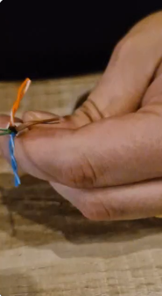
- Untwisting: The four twisted pairs (Orange, Green, Blue, Brown) are separated.

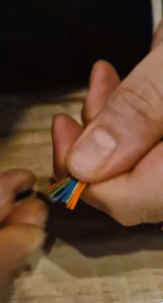
- Straightening: Each individual strand is straightened vigorously to ensure they glide into the RJ45 connector channels without overlapping or bending.

Phase 2: Standard Alignment (TIA-568B)
Adhering to the industry-standard color code is critical for signal integrity and cross-talk reduction.
- Ordering: The wires are arranged in the following exact sequence from left to right (with the RJ45 clip facing down):
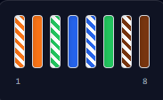
  - 1: White-Orange
  - 2: Orange
  - 3: White-Green
  - 4: Blue
  - 5: White-Blue
  - 6: Green
  - 7: White-Brown
  - 8: Brown
- Precision Trim: Once ordered and flattened, the wires are trimmed in a perfectly straight line using flush cutters, leaving roughly 1.5cm of exposed wire.

Phase 3: Termination & Crimping
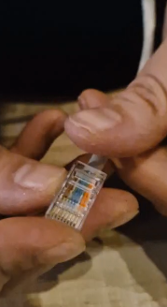
- Introduction: The wires are inserted into the RJ45 plug. A visual check is performed to ensure all 8 wires reach the end of the connector and sit directly under the gold pins.

- Strain Relief: The PVC jacket is pushed inside the connector past the crimp point to ensure the cable remains secure during handling.
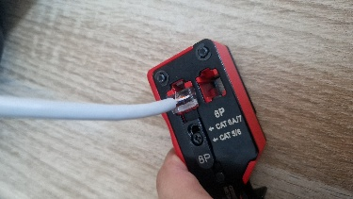
- Crimping: The tool is used to drive the gold-plated contacts through the wire insulation, creating a permanent electrical connection.

Quality Assurance & Validation
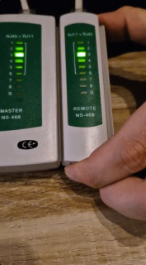
No cable is deployed into the "production" lab rack without passing a physical layer validation test.
- Continuity Test: Both ends of the cable are connected to a master/remote tester.

- Validation Criteria: A successful "1-through-8" sequential light pattern on the tester confirms 100% continuity and proper mapping.
- Result: The cable is certified for 1 Gbps throughput, ensuring stable connectivity.

Key Troubleshooting Highlights
- Wire Jump: If wires 3 and 6 cross, the cable will fail. Resolution: Re-straighten wires and hold with more tension before insertion.
- Poor Contact: If the tester shows a dead pin, the gold contact didn't pierce the wire. Resolution: Cut the end off and re-terminate with a new connector.

